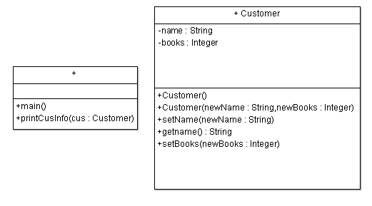

Class Customer

Private String name

Private Integer books

Public Module Customer()

Set name = “ “

Set books = 0

End Module

Public Module Customer(String newName, String newBooks)

Set name = newName

Set books = newBooks

End Module

Public Module setName (String newName)

Set name = newName

End Module

Public Function Integer getBooks()

Return books

End Function

Public Module setBooks (String newBooks)

Set books = newBooks

End Module

Module main()

Declare Customer john

Declare Customer sue

Set john = New Customer("John Smith", 8)

Call printCusInfo (john)

Set sue = New Customer("Sue Longo", 8)

Call printCusInfo (sue)

End Module

Module printCusInfo (Customer cus)

Display "Customer name: ", cus.getName ()

Display "Customer’s books purhcased.: ", cus.getBooks ()

End Module

Module printPoints (Customer cus)

Declare Integer books

Declare Integer points

Set points = cus.getPoints ()

If books >= 4 Then

Set points = "Points earned is 60"

Else If books == 3 Then

Set points = " Points earned is 30"

Else If books == 2 Then

Set points = " Points earned is 15"

Else If books == 1 Then

Set points = " Points earned is 5"

Else

Set points = "Points earned is 0"

End If

Display "Customer’s name is: " , cus.getName()

Display "Customer’s number of accumulated points is: " cus.getPoints()

End Module